

Experiment No.: 04

Title: Programing with Jenkins
Batch: B–1 Roll No.: 16010422234 Experiment No.: 04
______________________________________________________________________________

Aim: Executing Java program with Jenkins
______________________________________________________________________________

Resources needed: Jenkins, Java
______________________________________________________________________________

Theory:
Manage plugins: To install plugins for integration with Jenkins.
Global Tool Configuration: To Configure plugins for integration with Jenkins

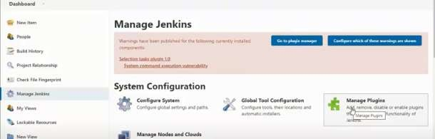
______________________________________________________________________________

Procedure:
Java parametrized Programming [Explicit]
- Create New item-> freestyle project this project is parametrized
- Set two string parameter num1 and num2
- Select build tab->window batch command, write command and build
______________________________________________________________________________

Results: (Document with screenshots)

1. All steps to execute Explicit java parametrized program.
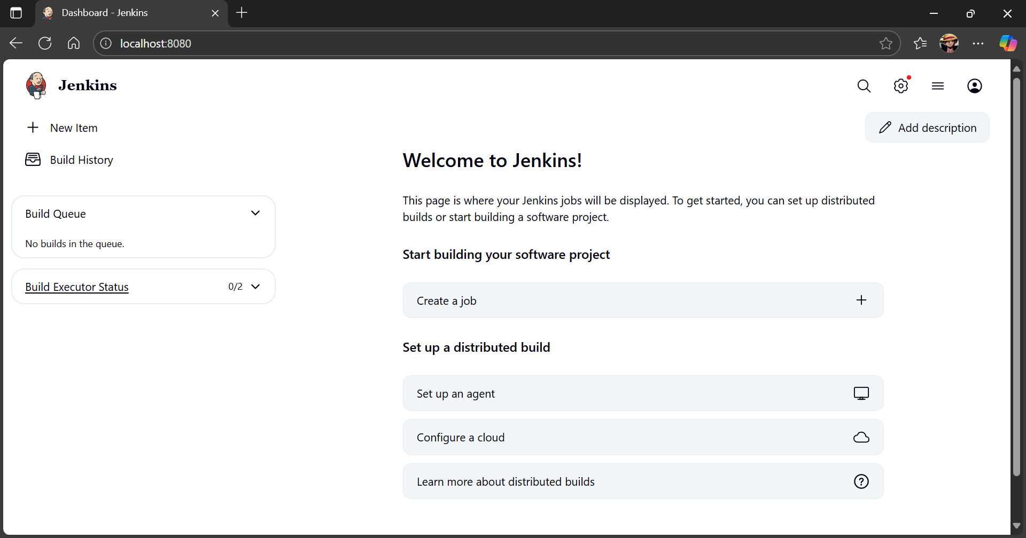

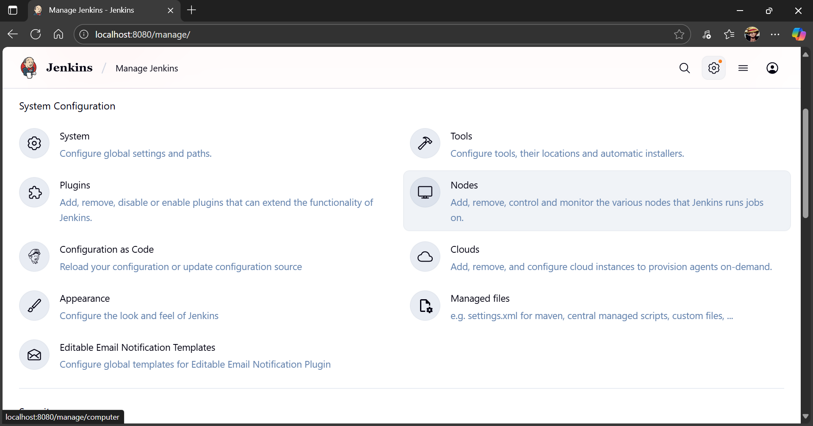
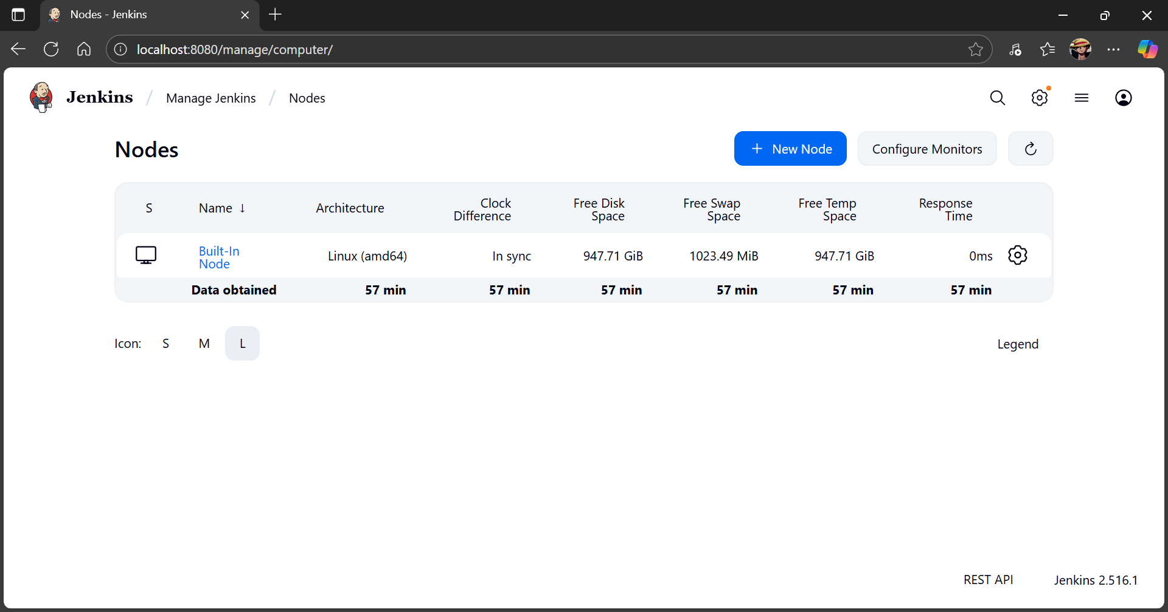

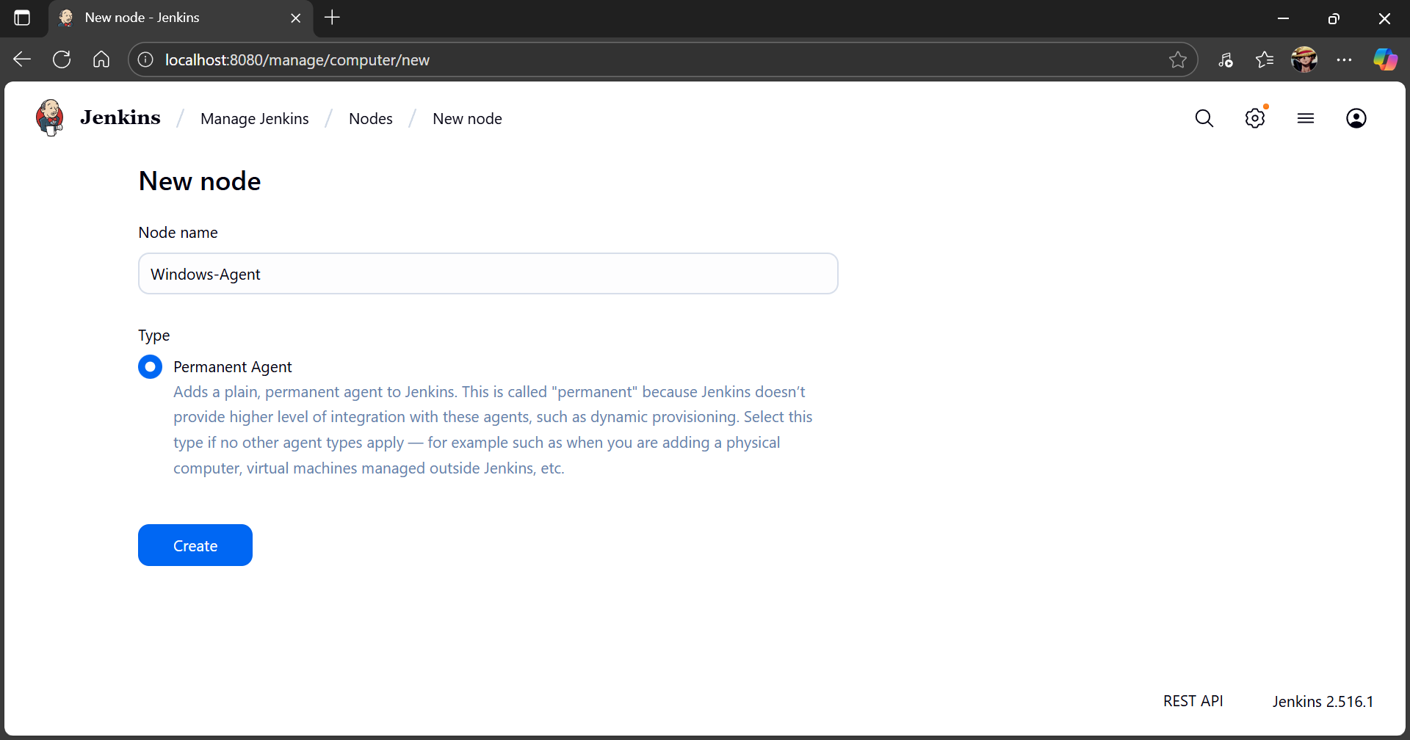
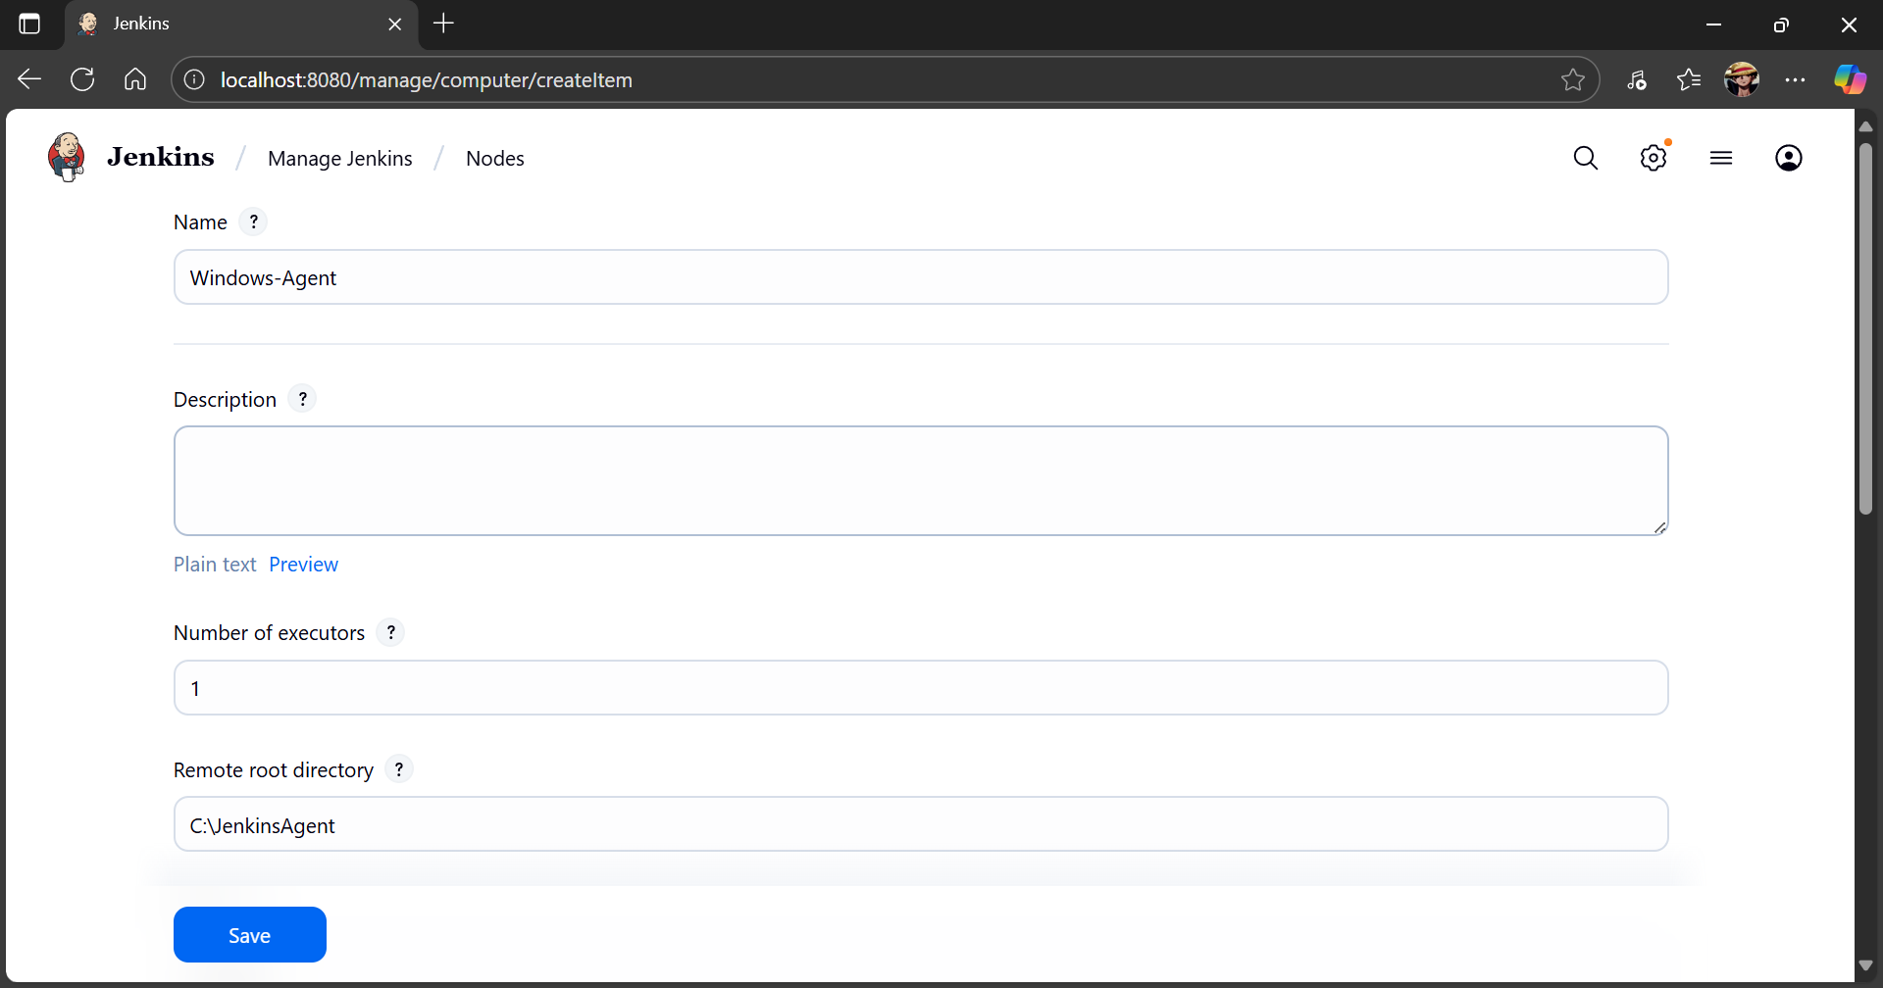

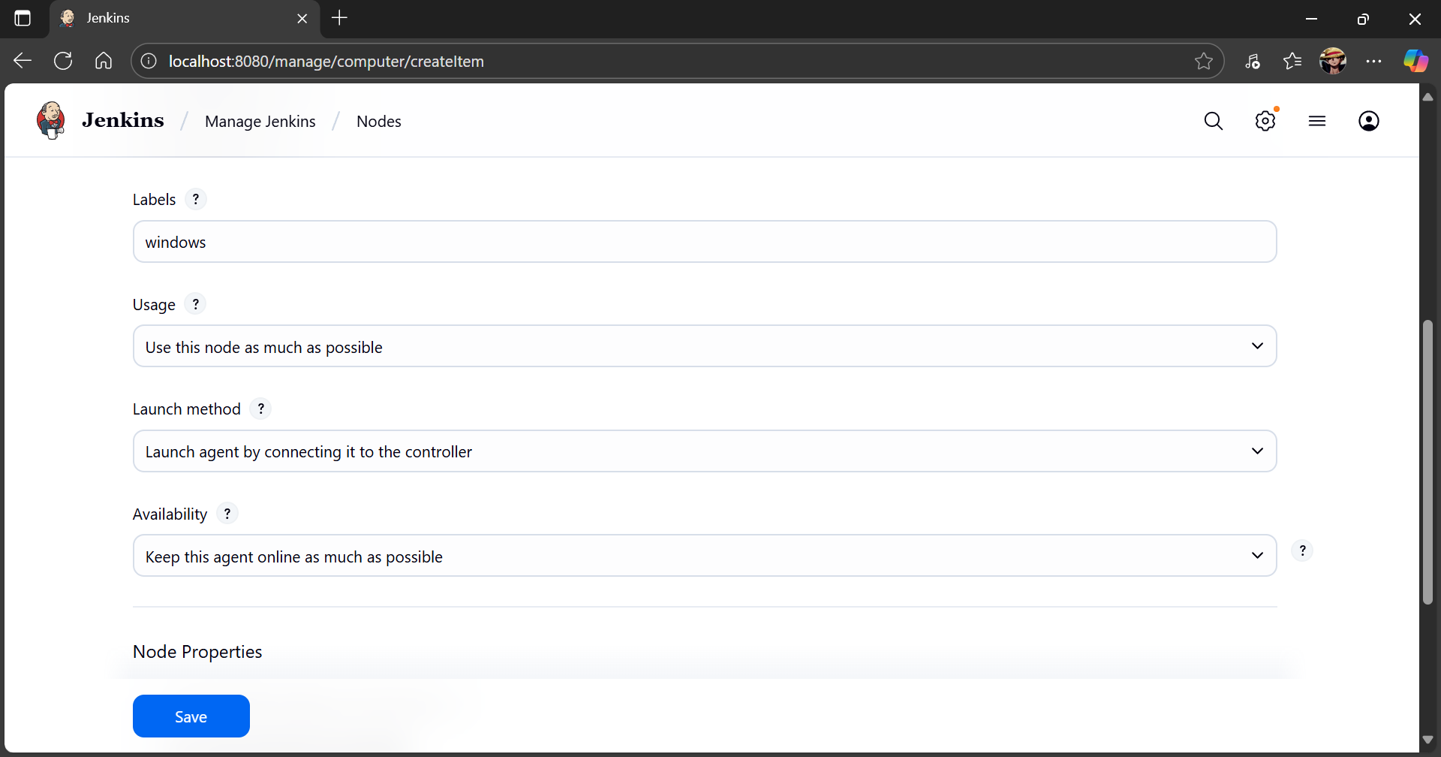
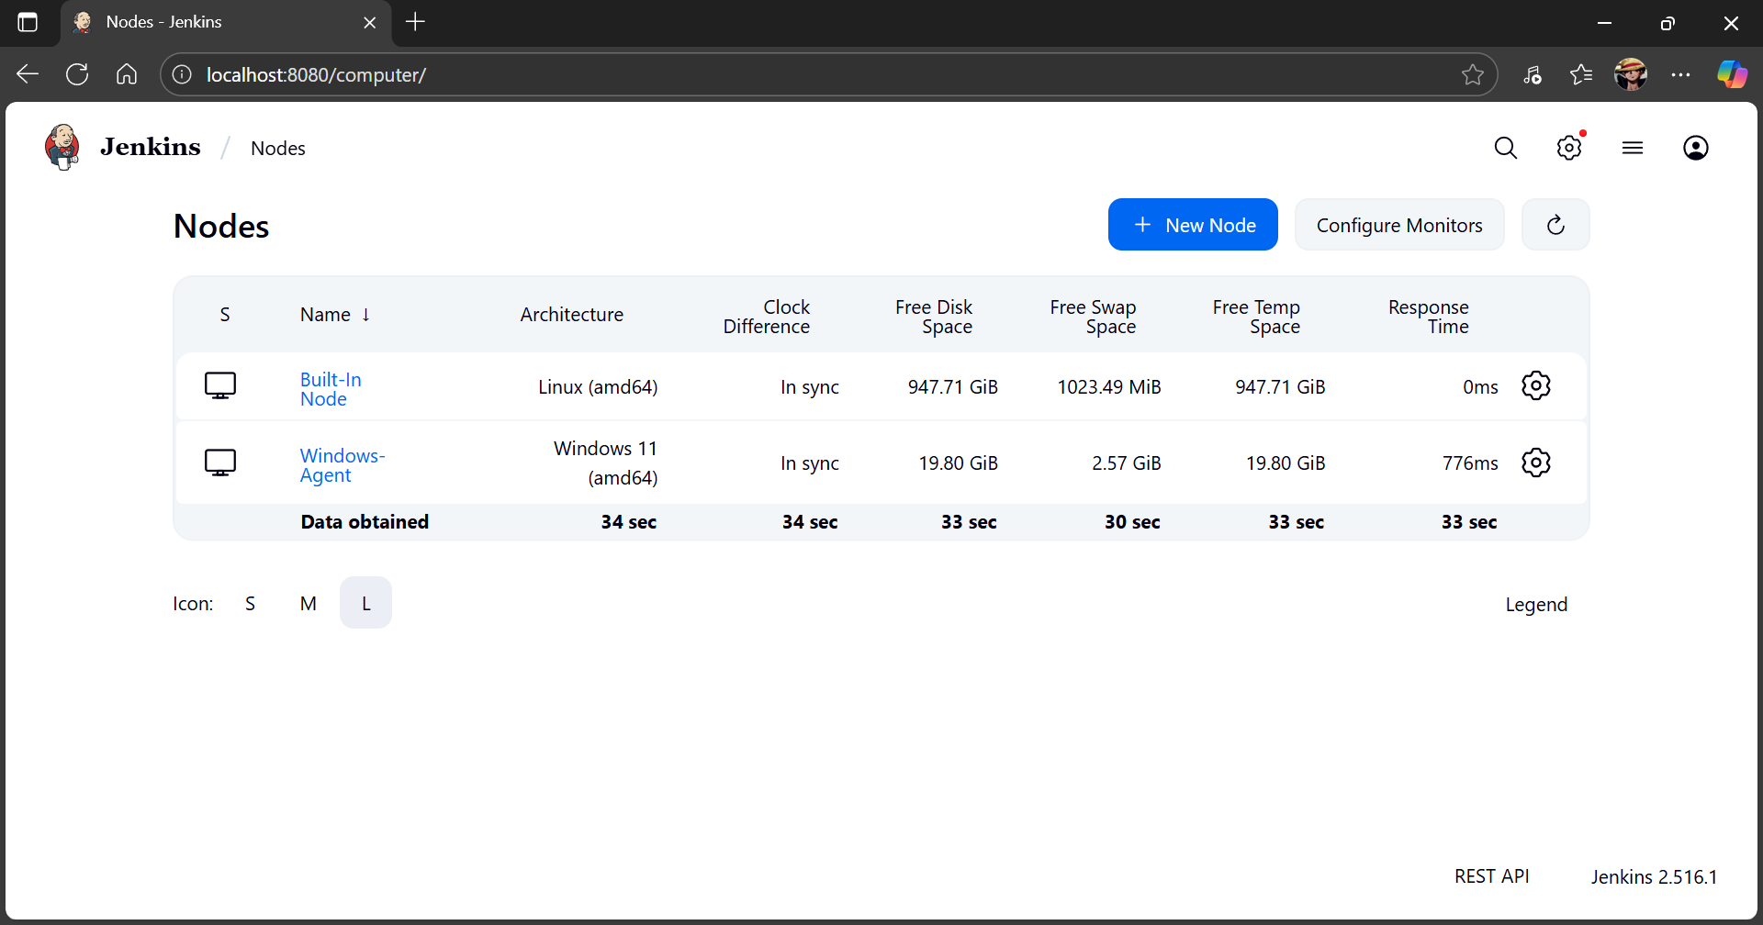


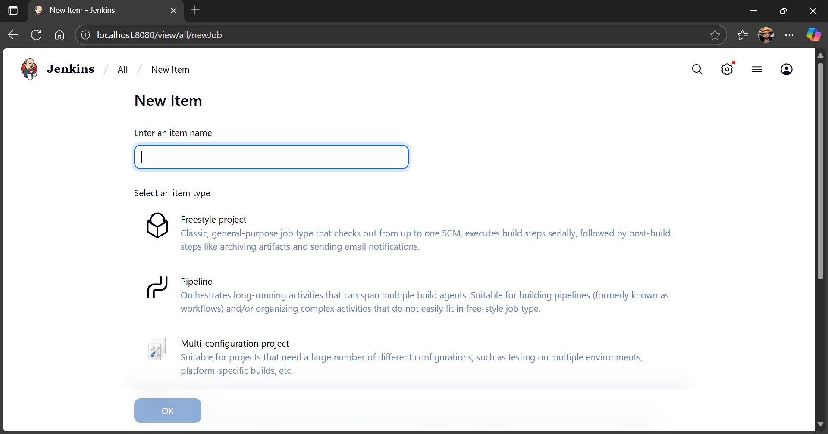

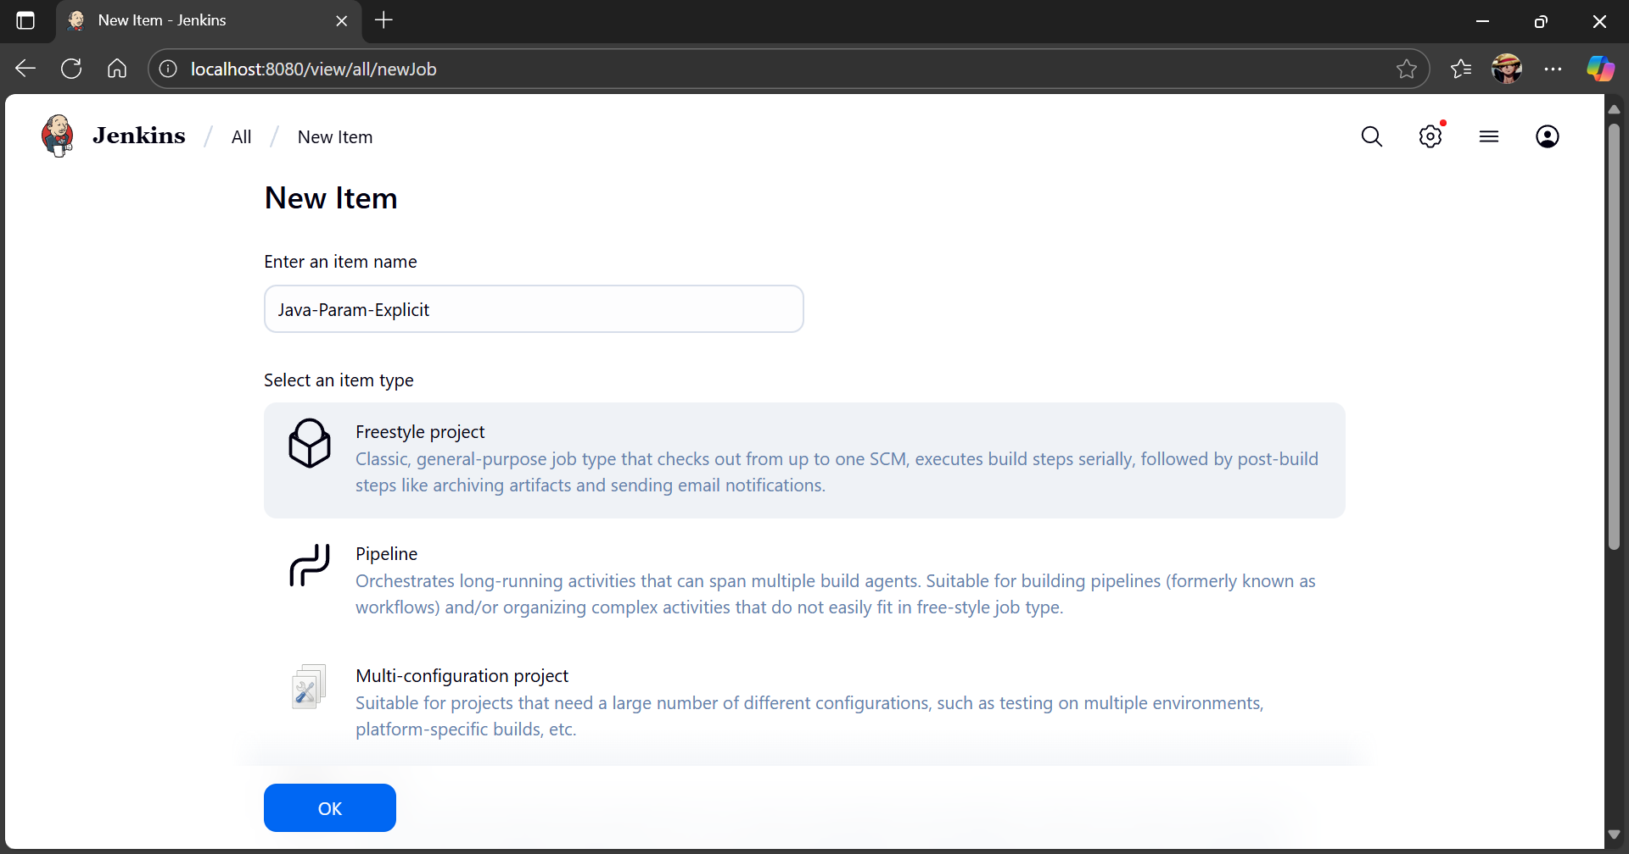
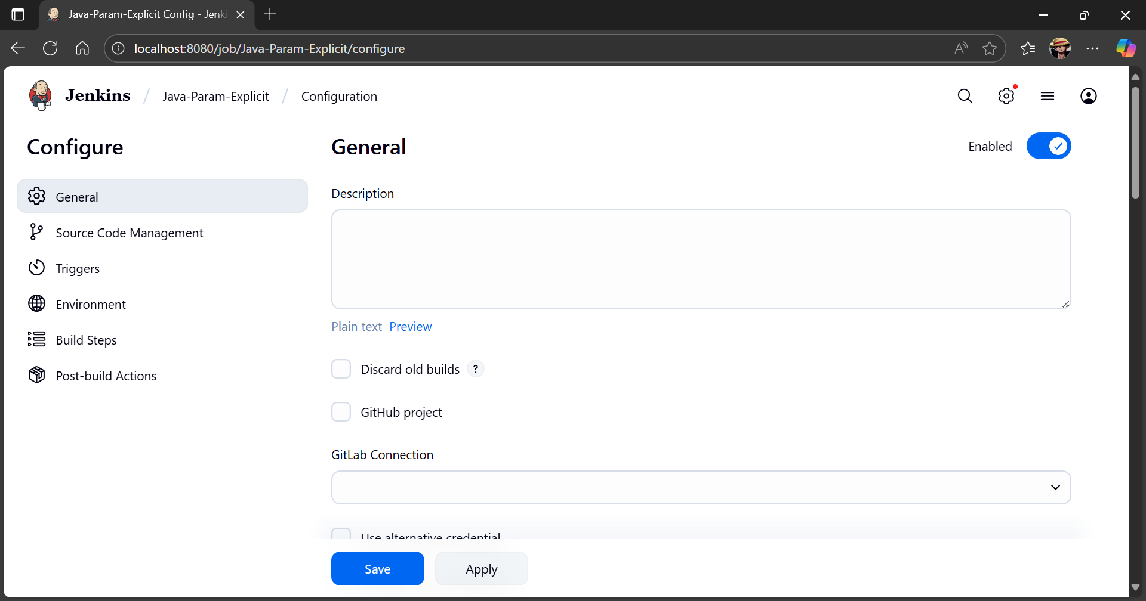

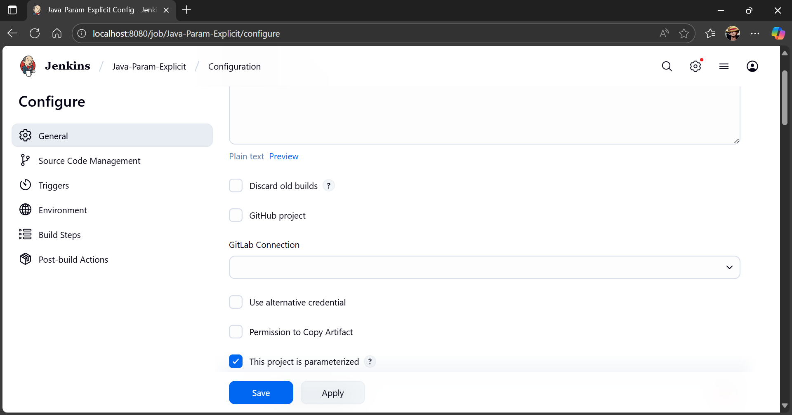
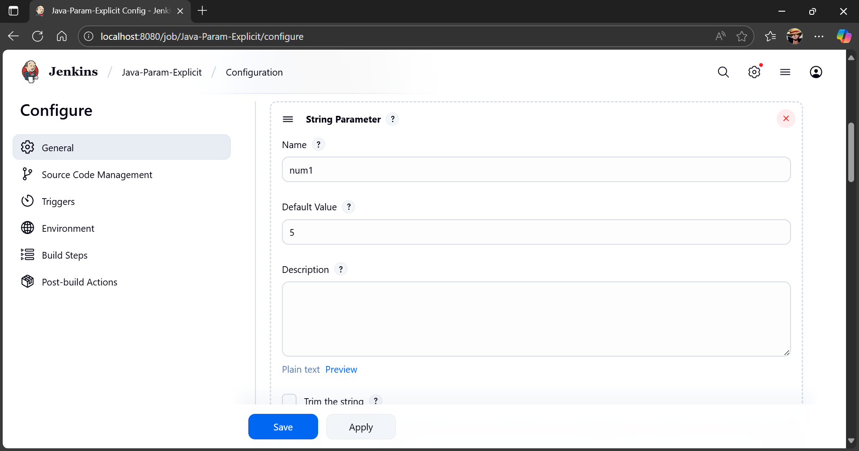

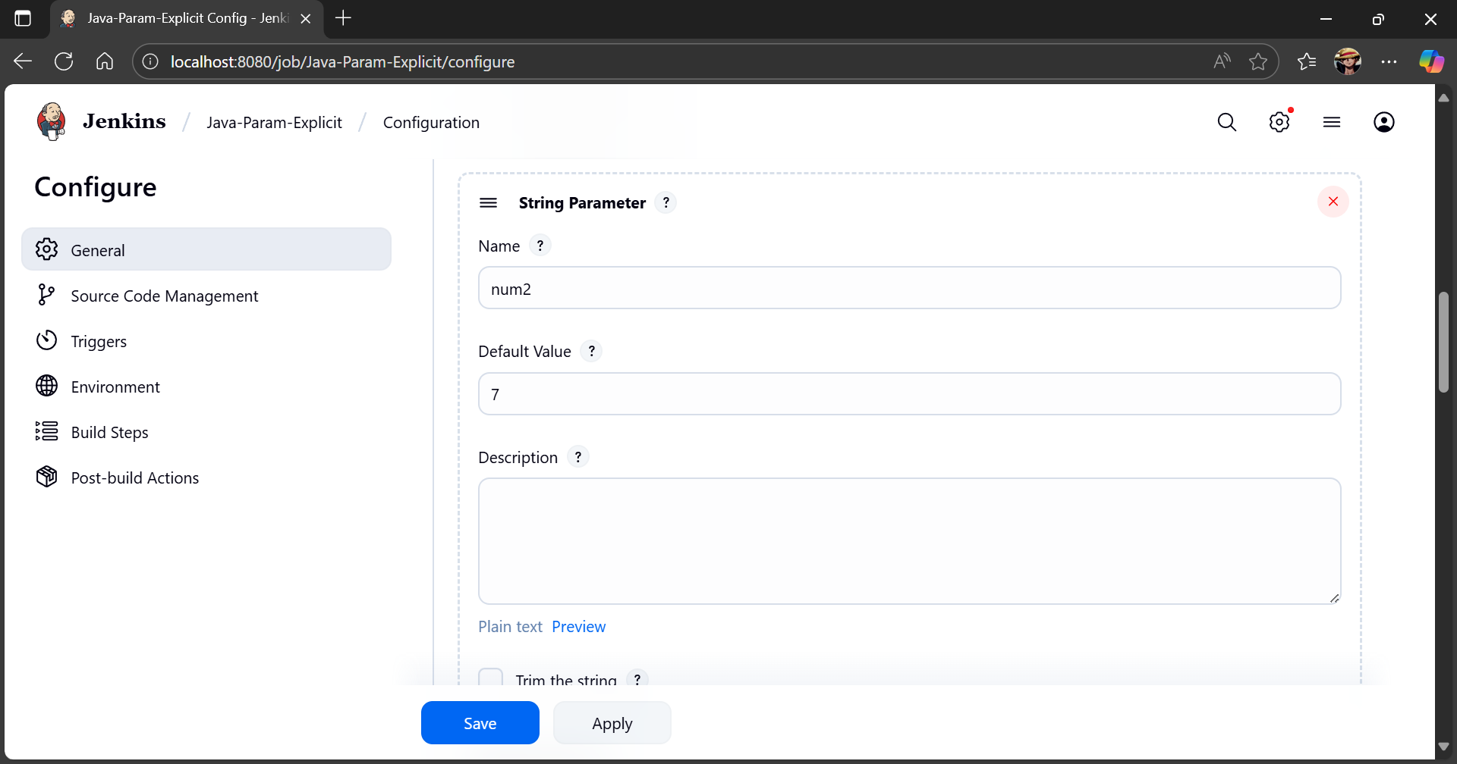
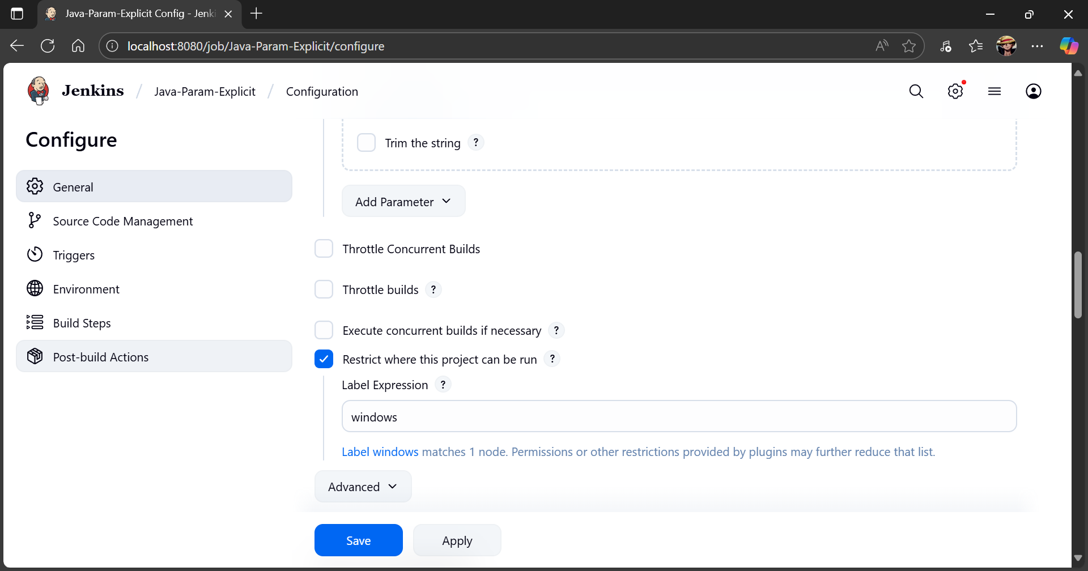

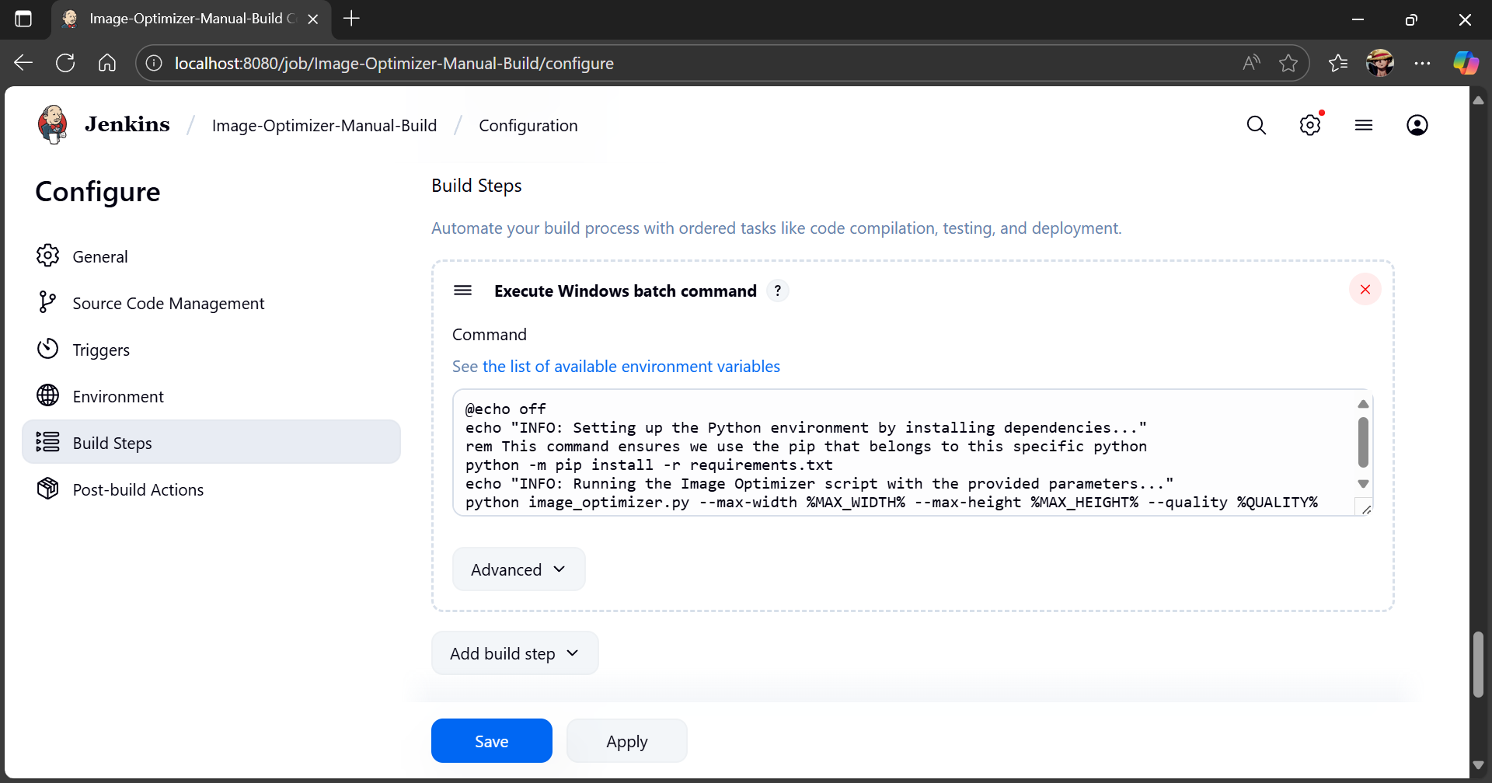
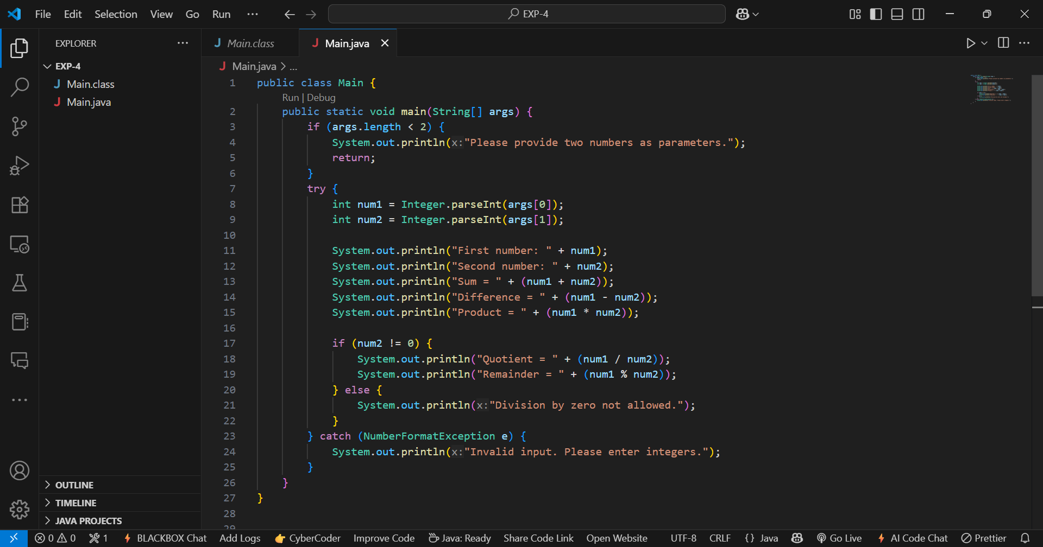

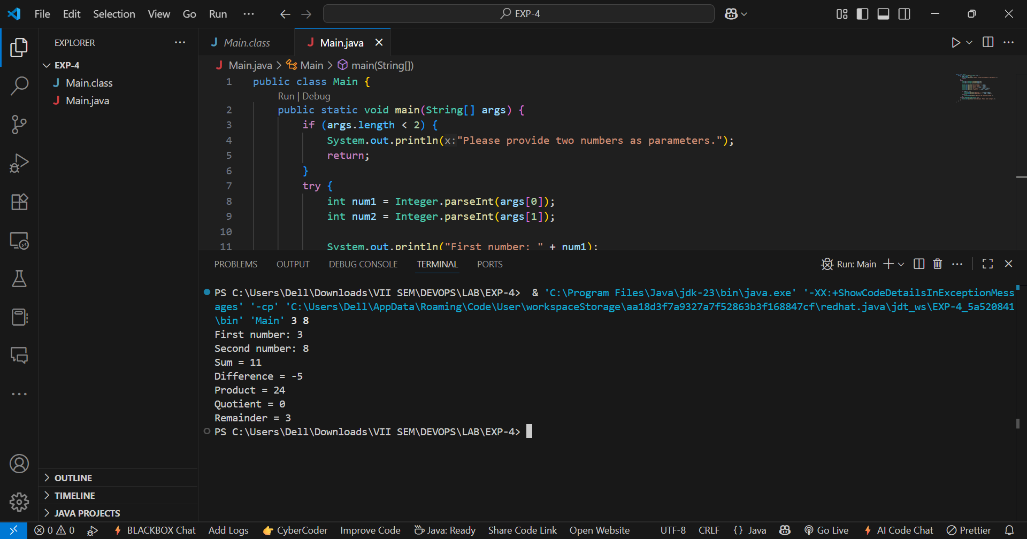
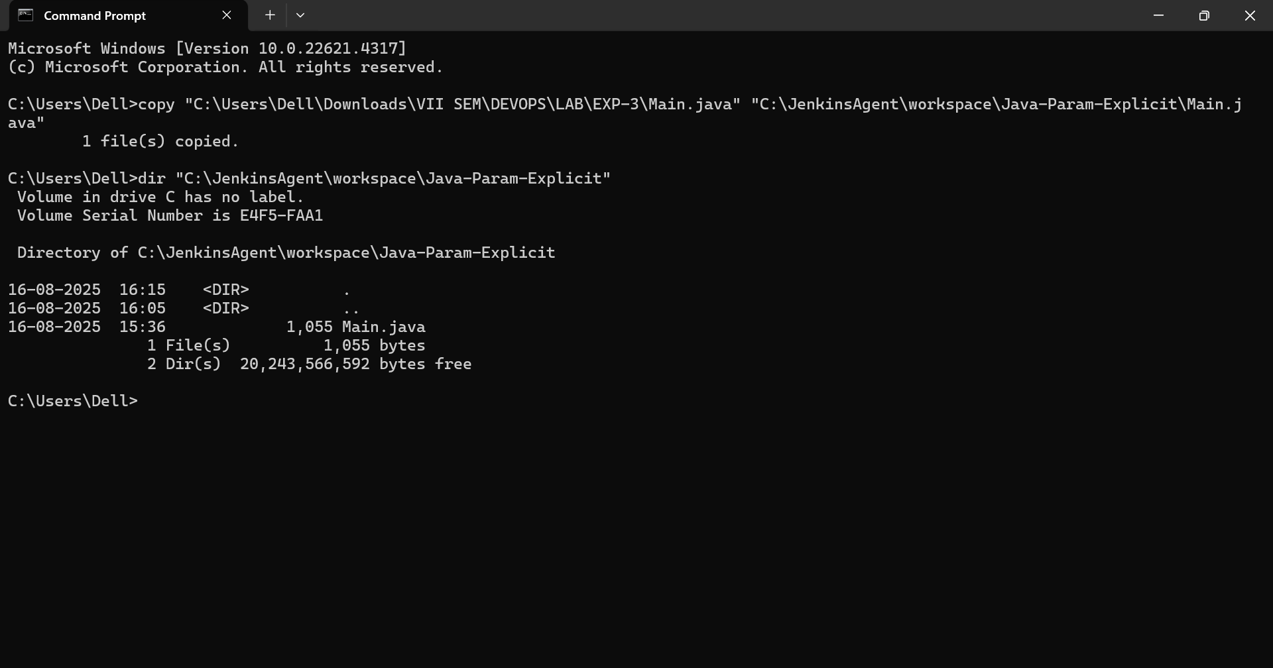

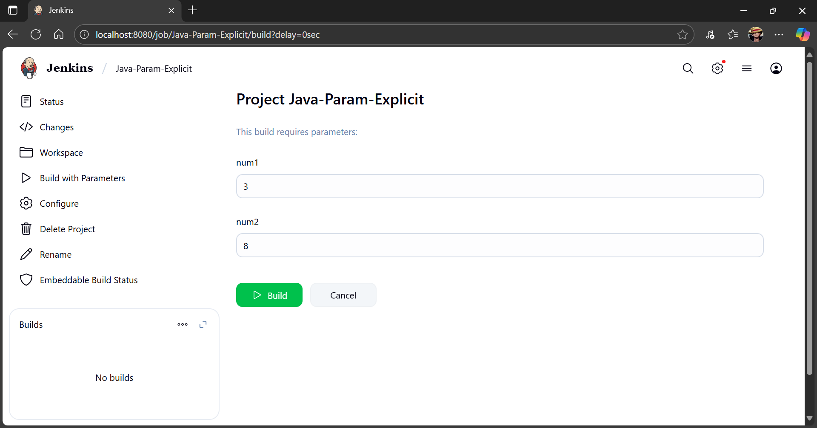
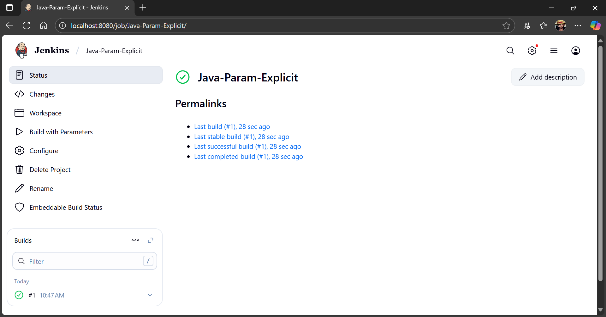

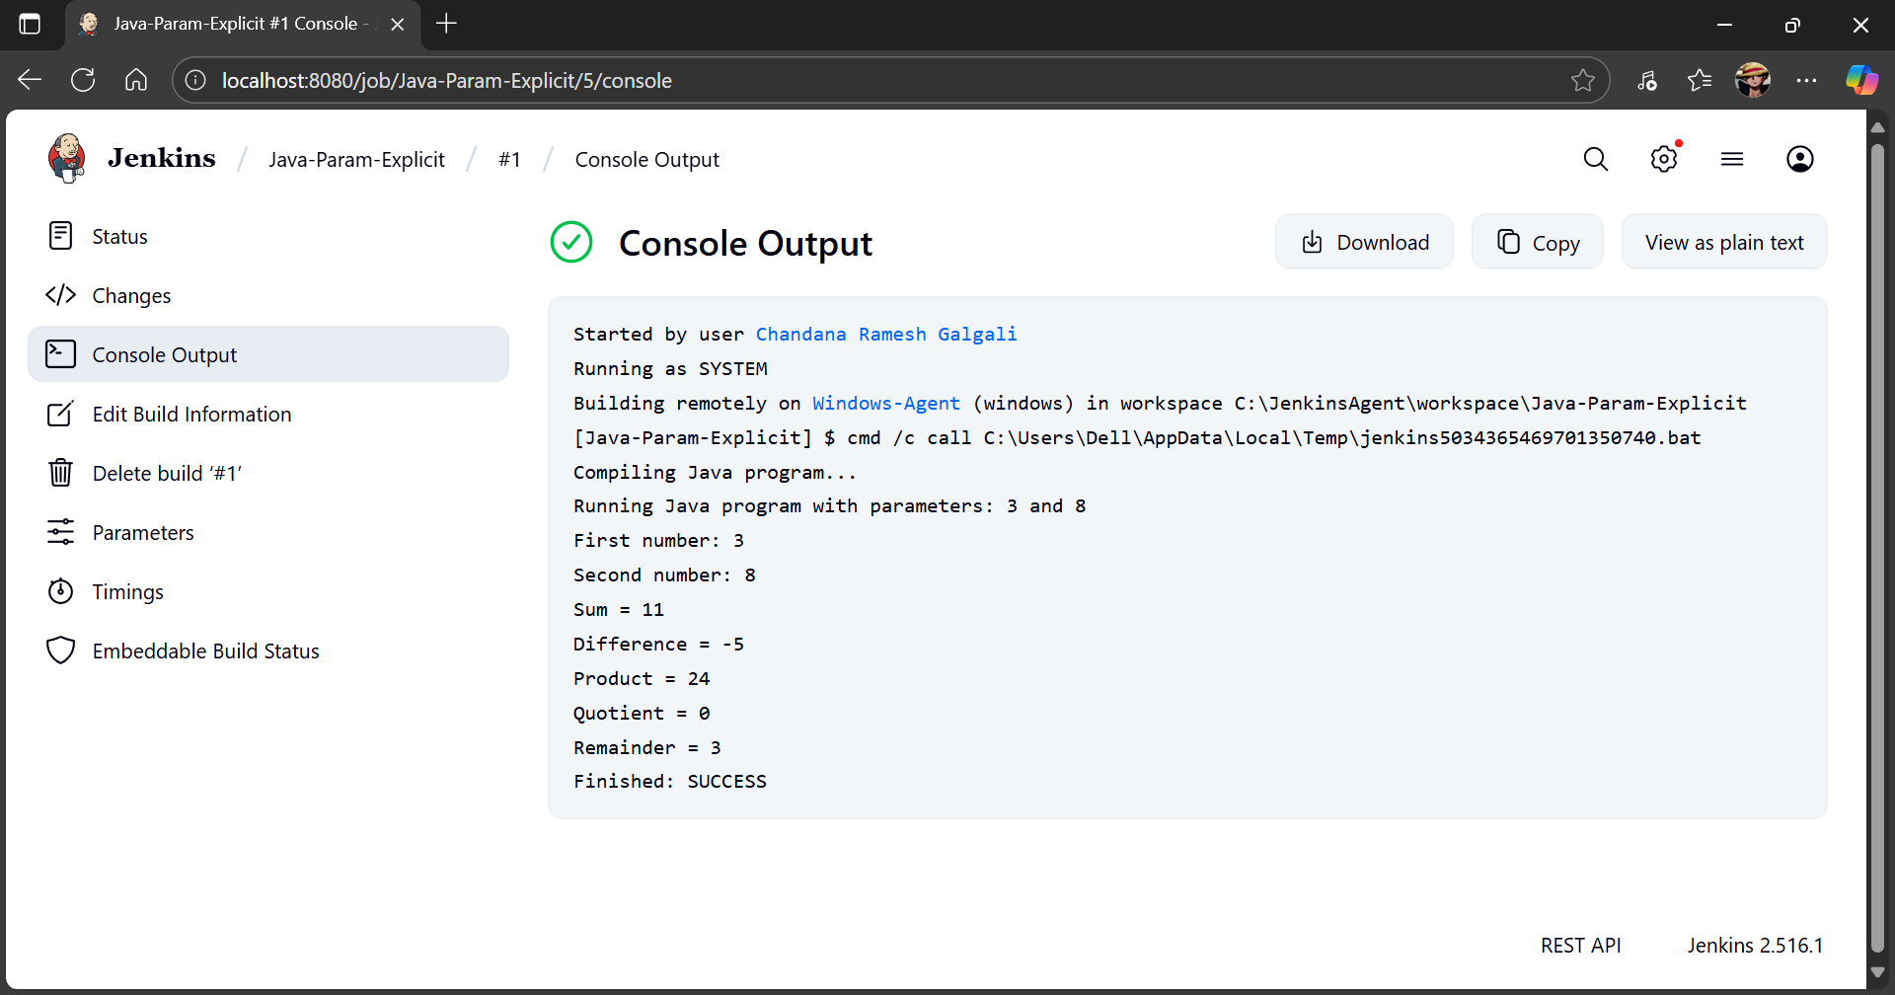

Image-Optimizer-Manual-Build

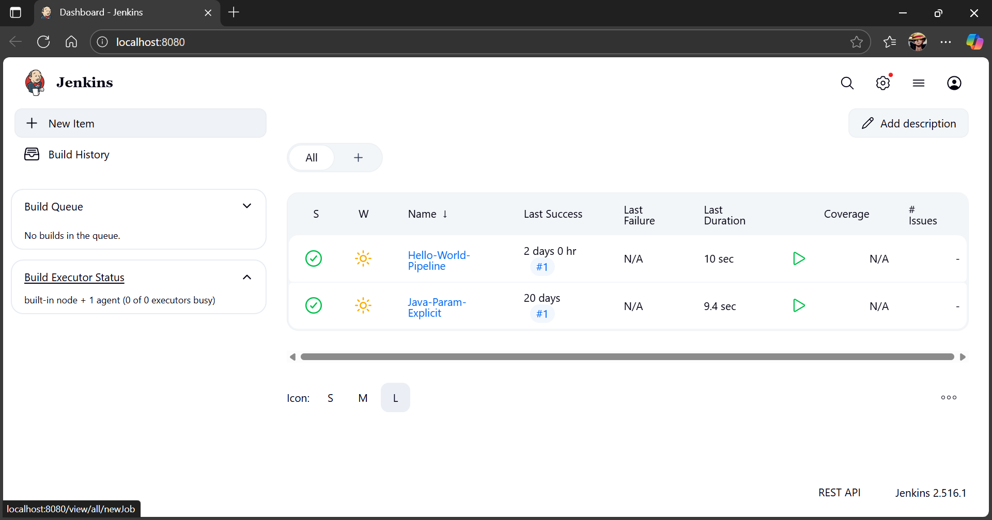

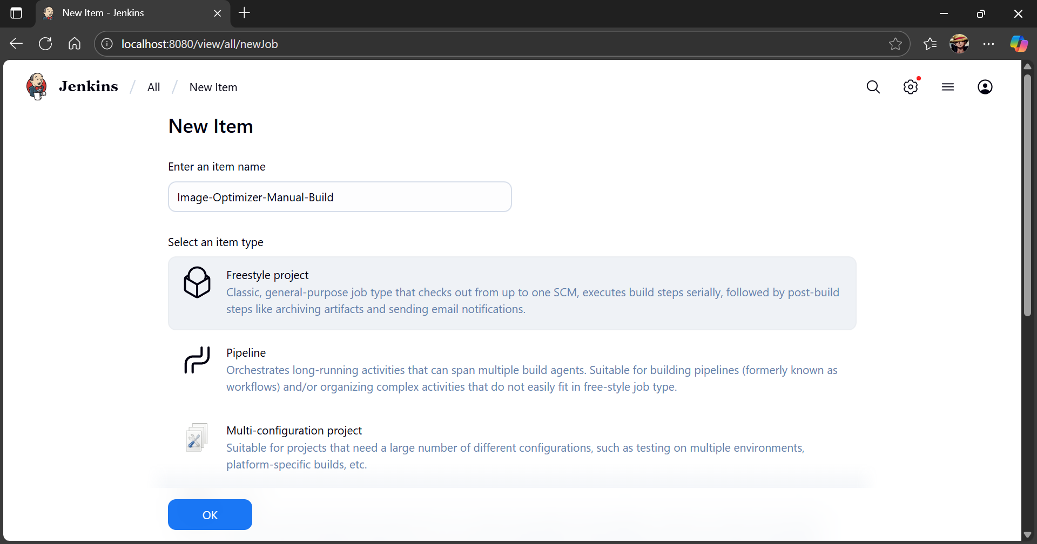

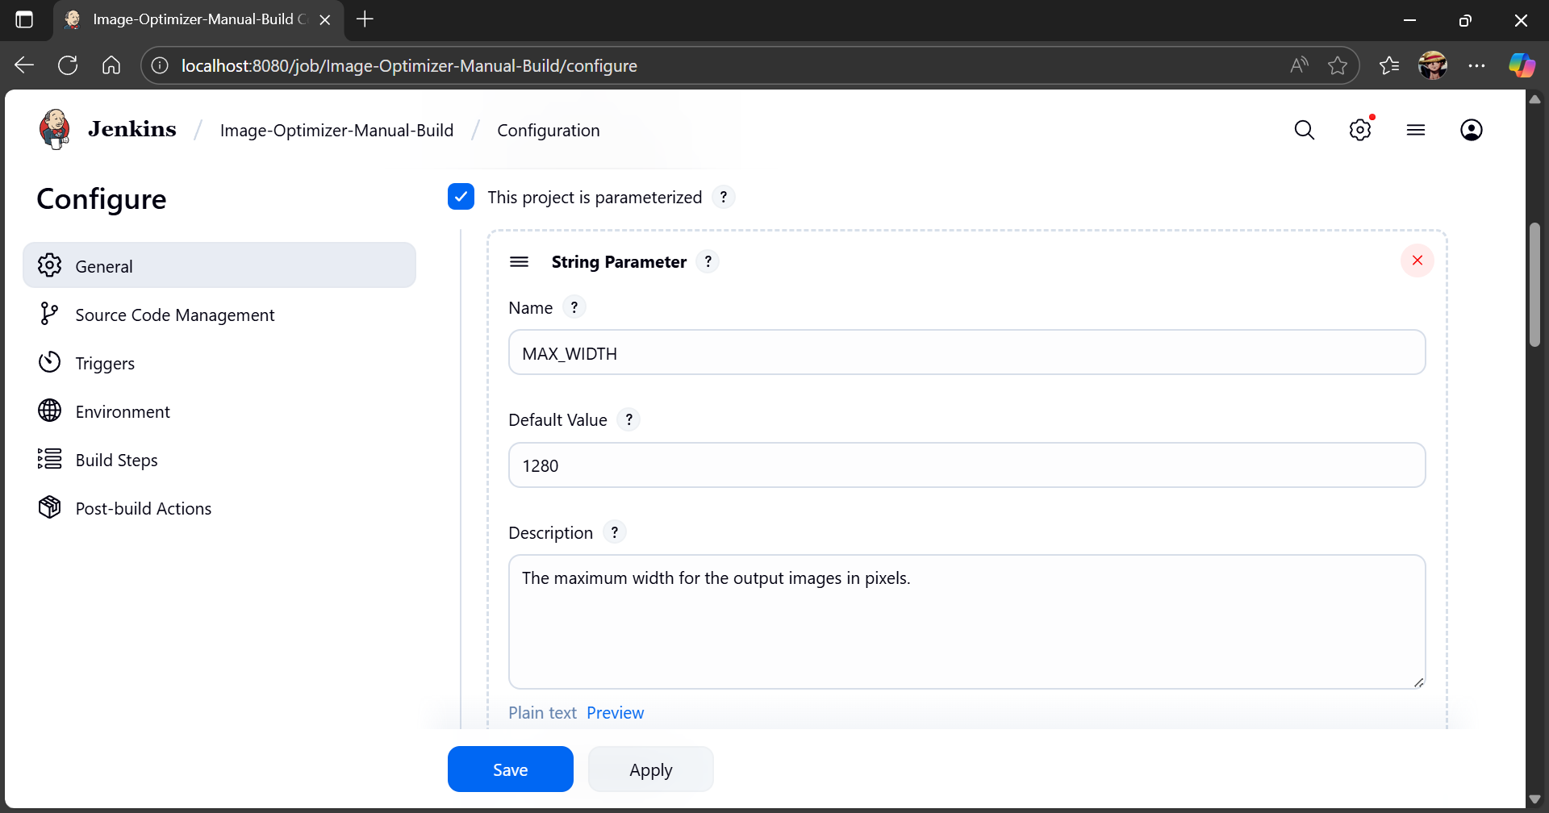

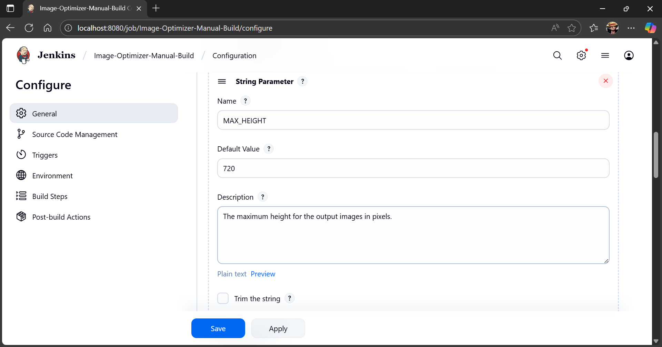

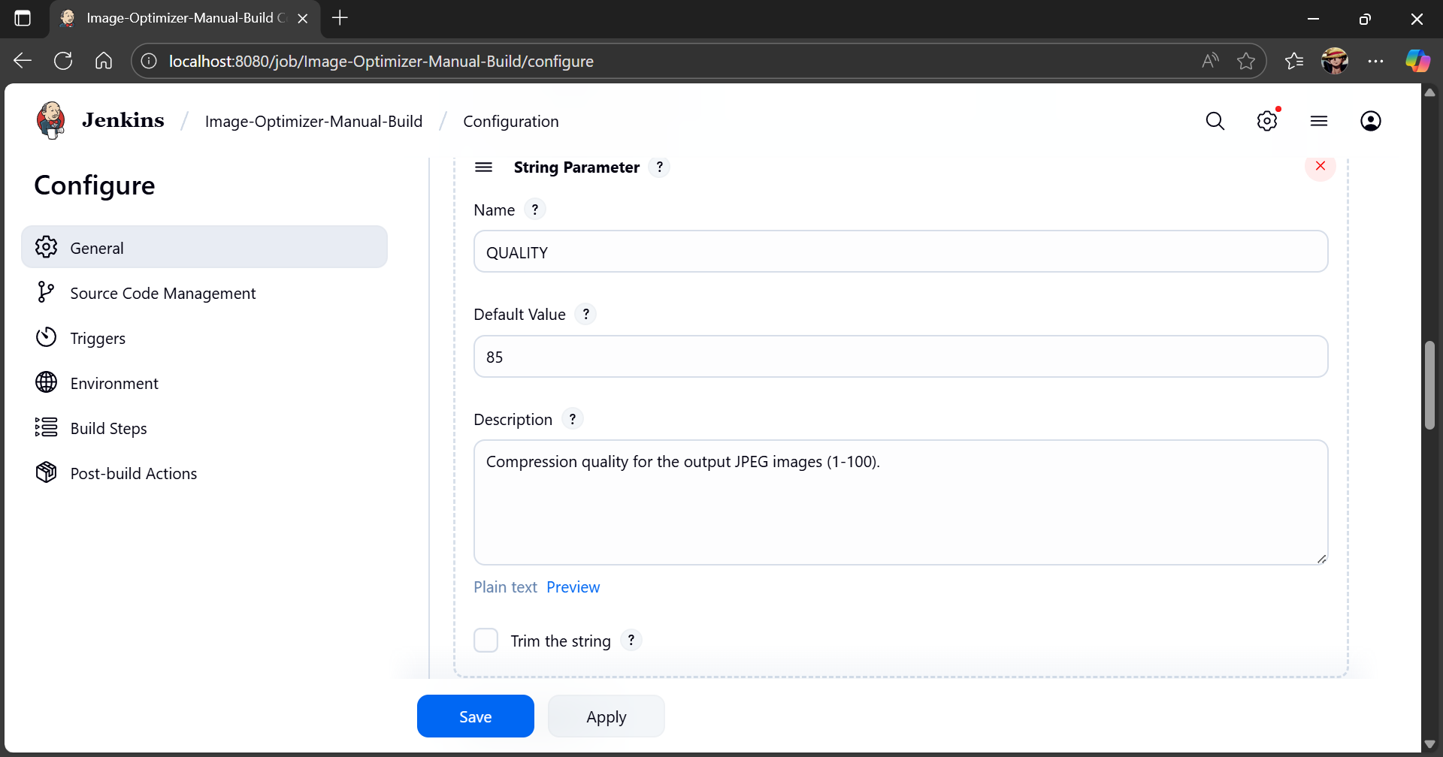

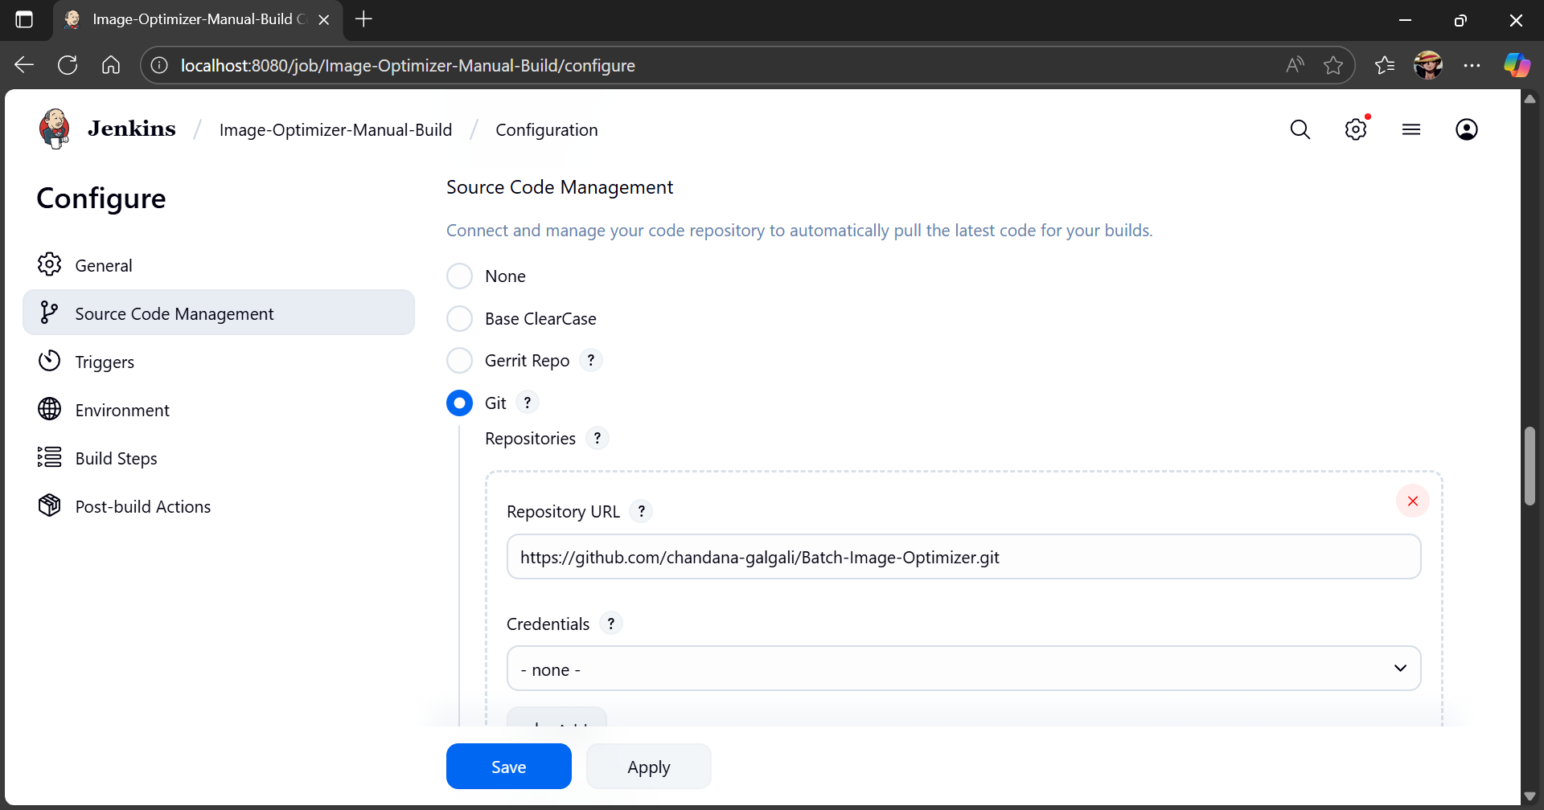

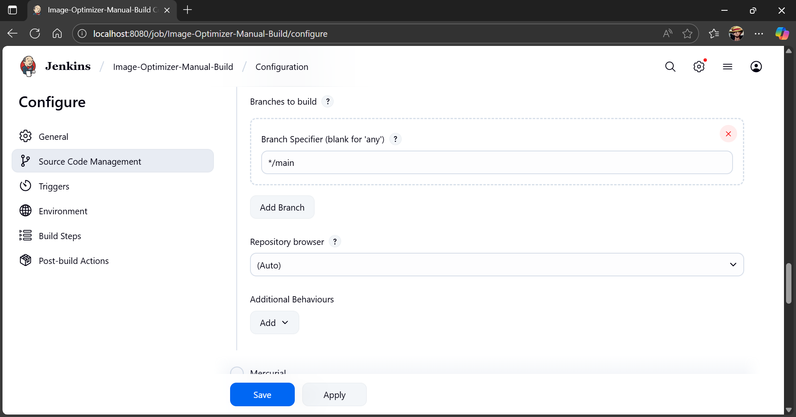

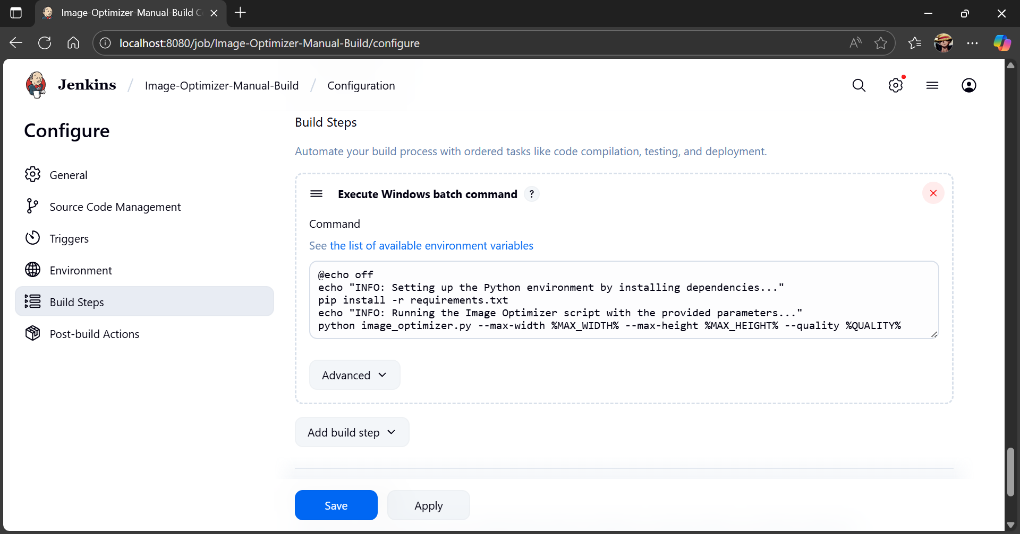



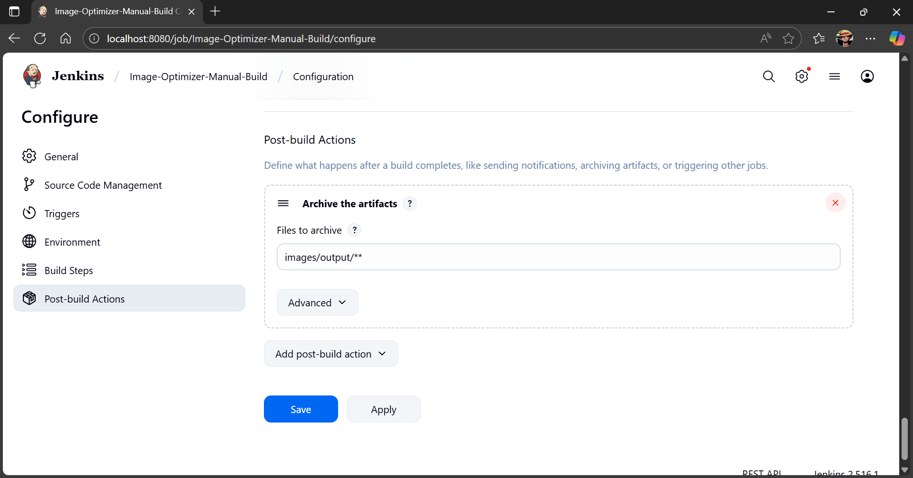

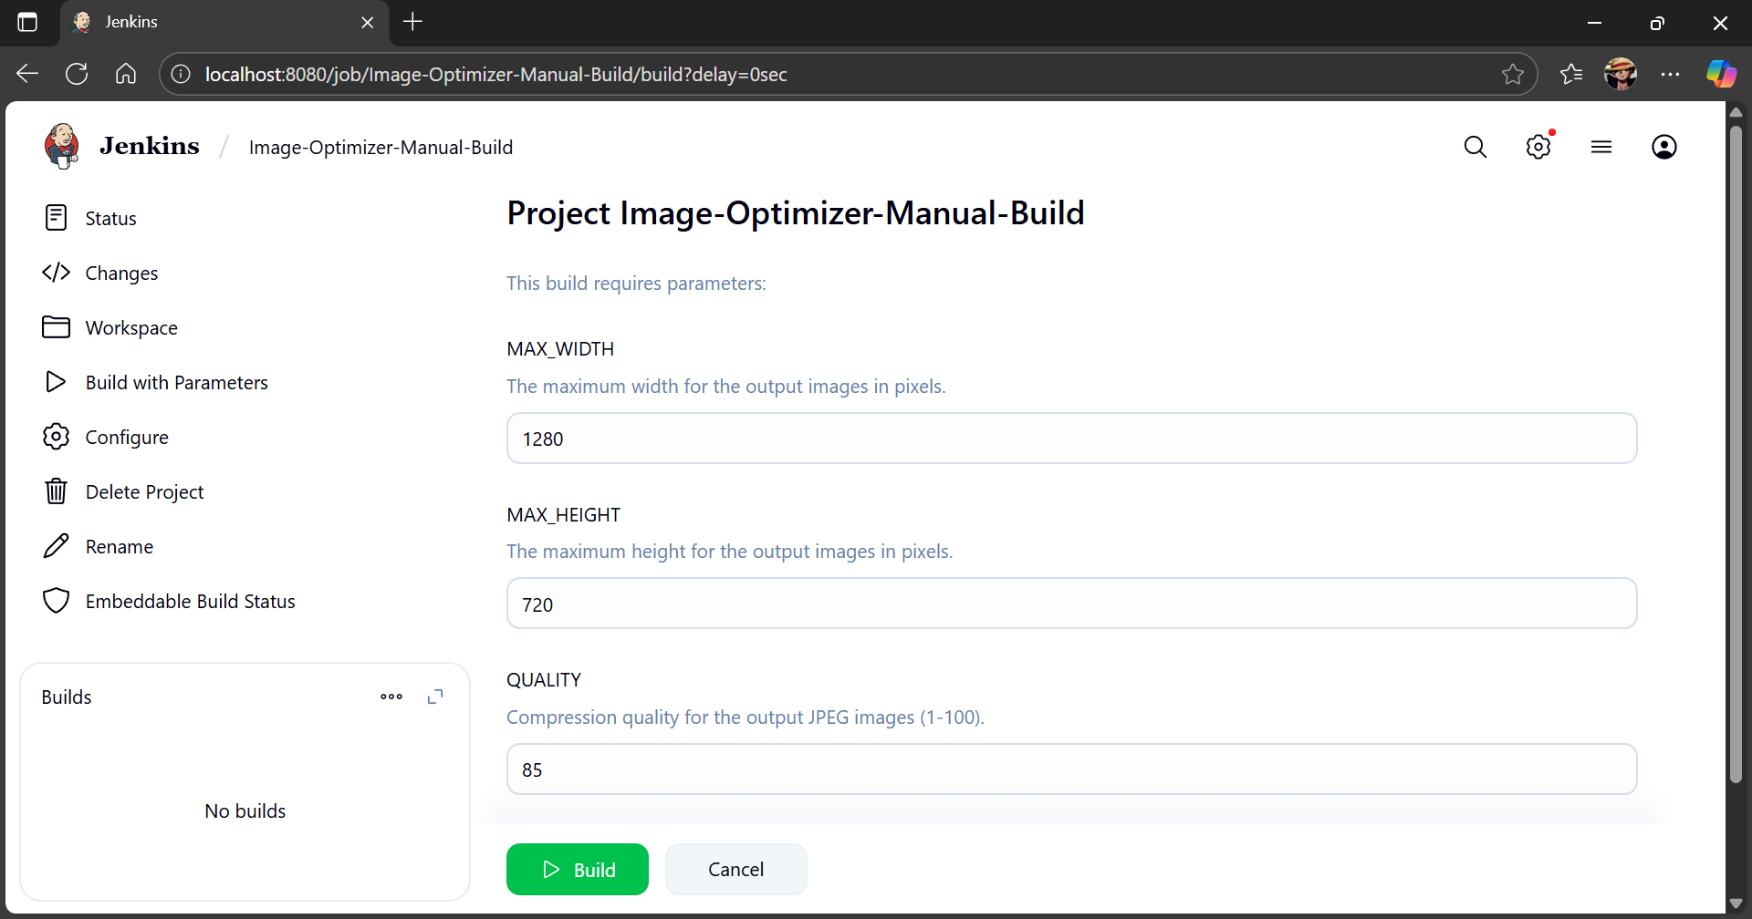

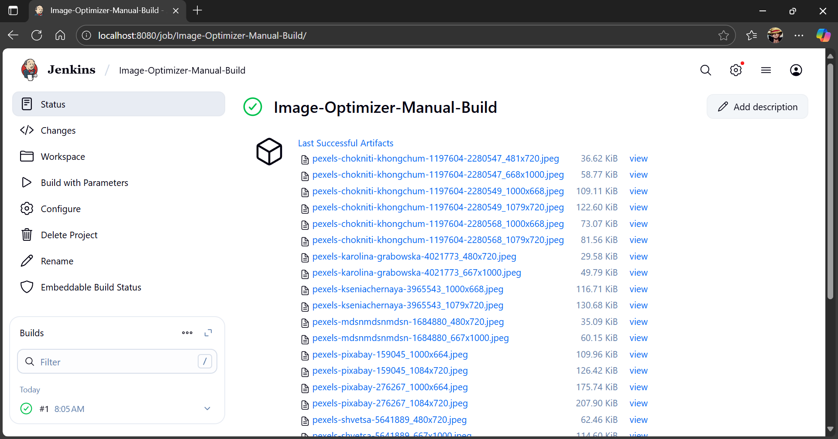

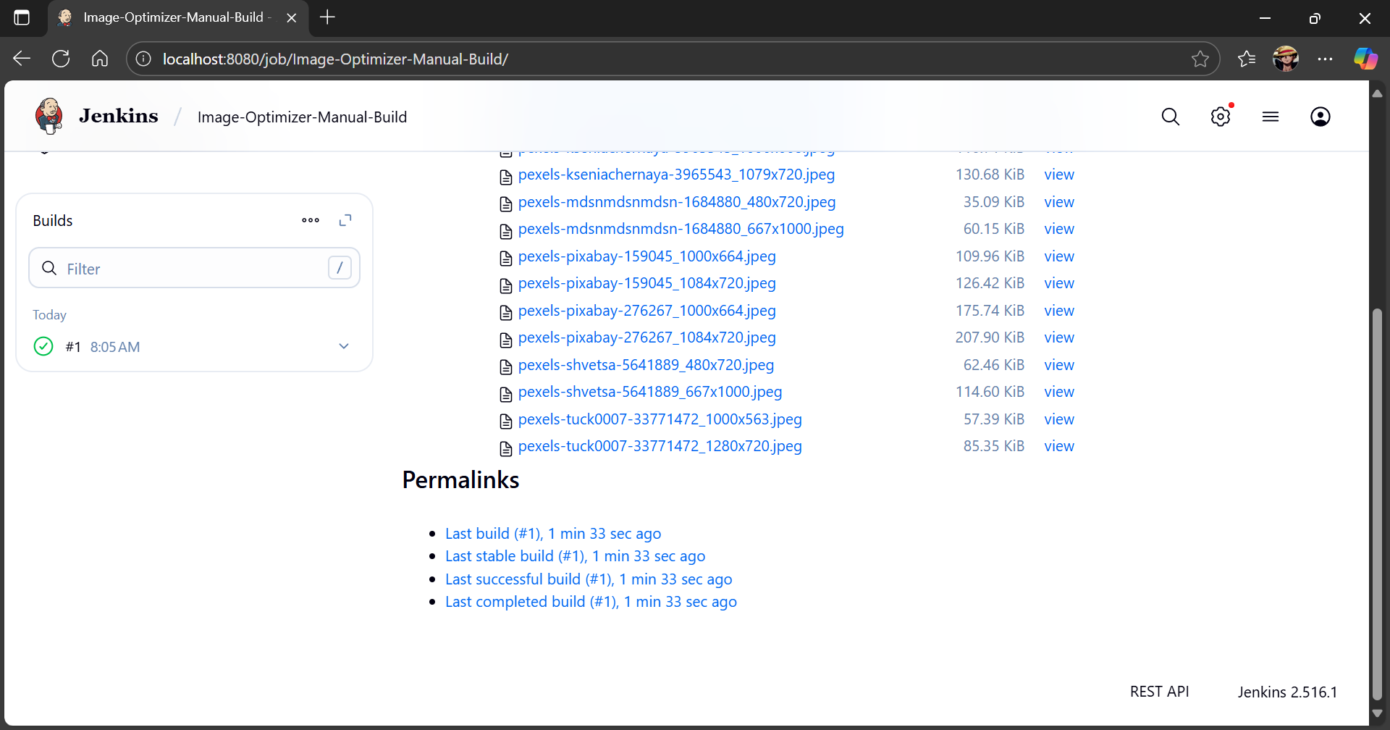

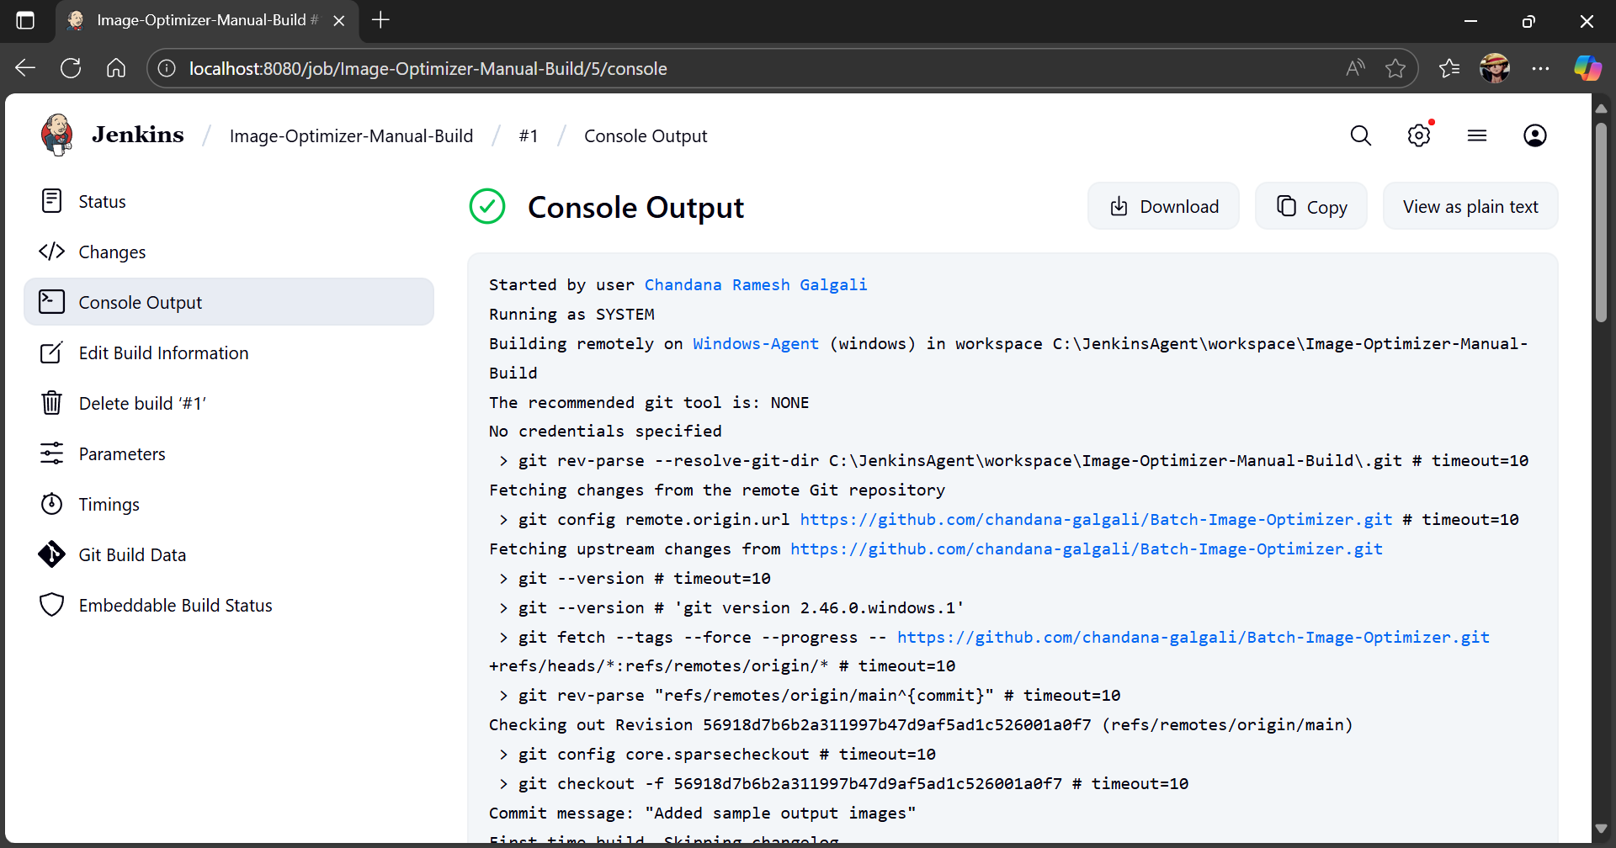

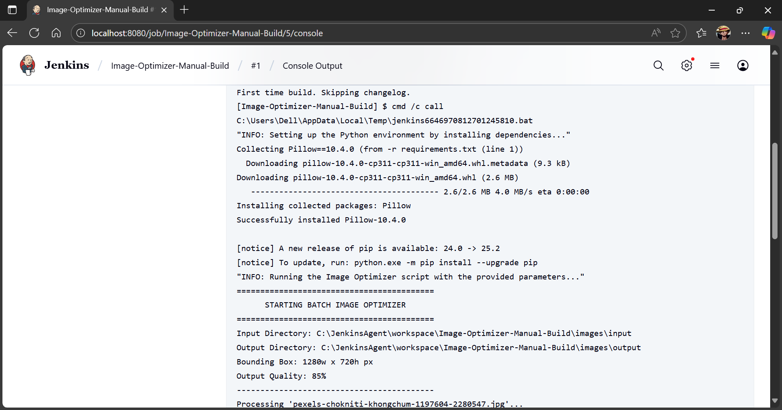

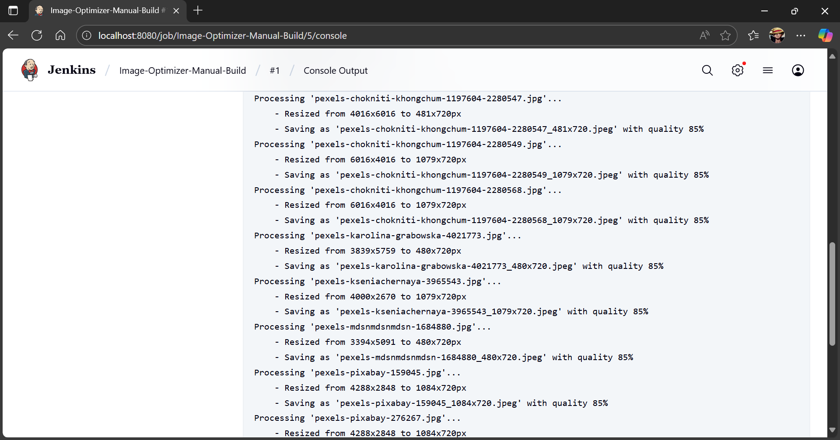

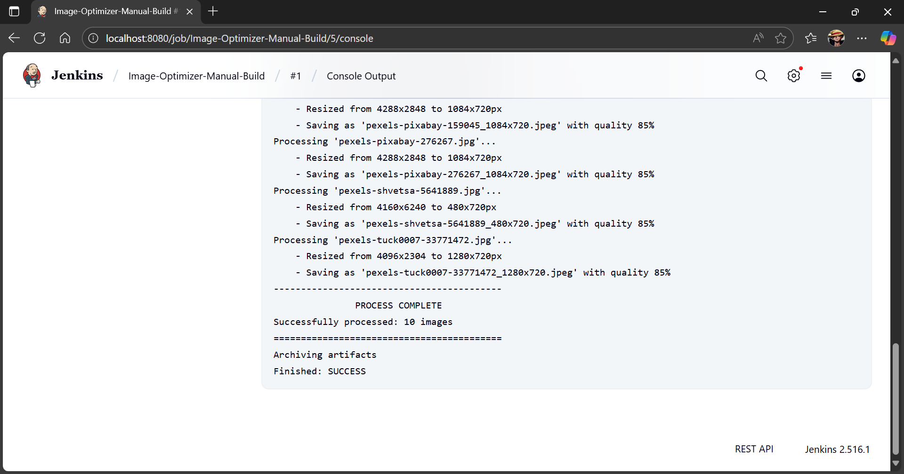

______________________________________________________________________________

Questions:

1. Explain the difference between system configuration and global tool configuration.
Ans:

Aspect | System Configuration | Global Tool Configuration
Purpose | Used to configure overall Jenkins settings, including security, system messages, environment variables, paths, and connected services. | Used to define and configure development tools that Jenkins will use (Java, Git, Maven, etc.).
Scope | Applies to the entire Jenkins server setup and environment. | Applies to the tools available for Jenkins jobs.
Example | Setting up Jenkins URL, managing nodes, email notifications, environment variables. | Setting up JDK installations, Git executable paths, Maven versions.
Effect | Affects how Jenkins as a whole runs and interacts with its environment. | Affects how build jobs find and use necessary tools for execution.

______________________________________________________________________________

Outcomes: CO3 – Comprehend the effective code building and testing process
______________________________________________________________________________
Conclusion: (Conclusion to be based on the Results and outcomes achieved)
By successfully executing a Java program using Jenkins with explicit parameterization, we automated the build process and allowed dynamic input values through parameters (num1 and num2). This demonstrated how Jenkins can efficiently integrate code compilation, parameter handling, and execution without manual intervention, ensuring faster and more reliable testing. The outcome shows the importance of continuous integration practices in maintaining code quality and flexibility.
______________________________________________________________________________

Grade: AA / AB / BB / BC / CC / CD / DD

Signature of faculty in-charge with date
______________________________________________________________________________

References:
Books/ Journals/ Websites:
- https://www.tutorialspoint.com/jenkins/index.htm
- https://www.guru99.com/create-builds-jenkins-freestyle-project.html
- Effective DevOps: Building a Culture of Collaboration, Affinity, and Tooling at Scale, Jennifer Davis, Ryn Daniels, O'Reilly Media June 2016.
- Practical DevOps: Implement DevOps in your organization by effectively building, deploying, testing, and monitoring code, Joakim Verona, Packt Publishing, 2nd Edition, 2016
______________________________________________________________________________

